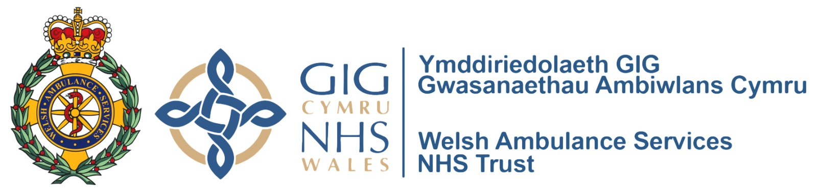

ANNUAL GENERAL MEETING
WELSH AMBULANCE SERVICES NHS TRUST

To be conducted using the media platform Zoom

Thursday 1 October at 09:30am

09:30 – 09:40 | Welcome and Introductions | Martin Woodford, Trust Chairman
09:40 – 09:50 | Video
09:50 – 10:15 | CEO Update | Jason Killens, Chief Executive
10:15 – 10:30 | Finance Update | Chris Turley, Director of Finance and Corporate Resources
10:30 – 11:00 | Q and A Session | Estelle Hitchon, Director of Partnerships and Engagement
11:00 – 11:15 | Thanks and closing remarks | Martin Woodford, Trust Chairman

